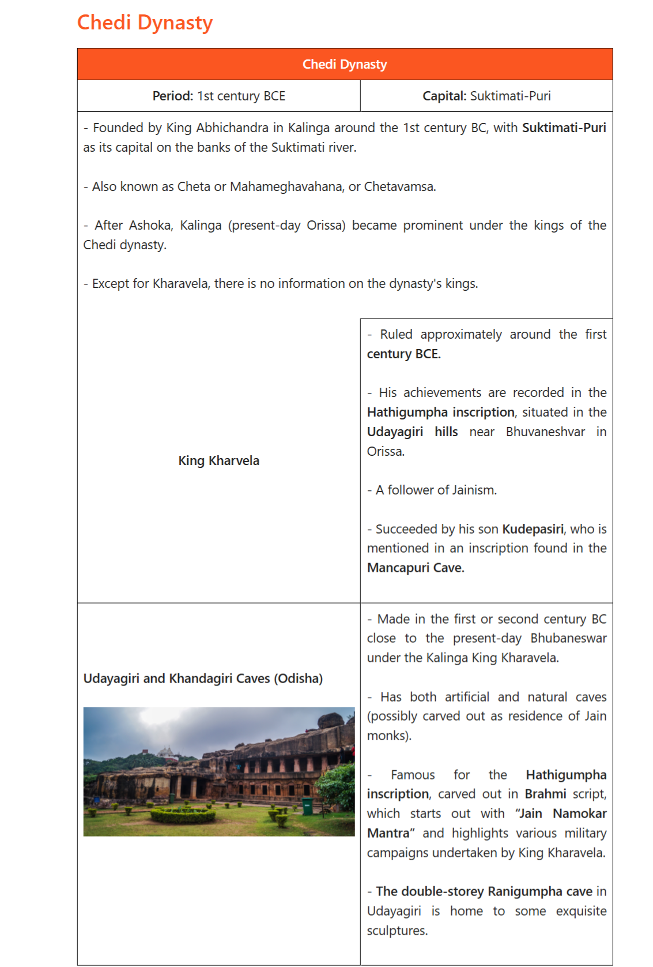

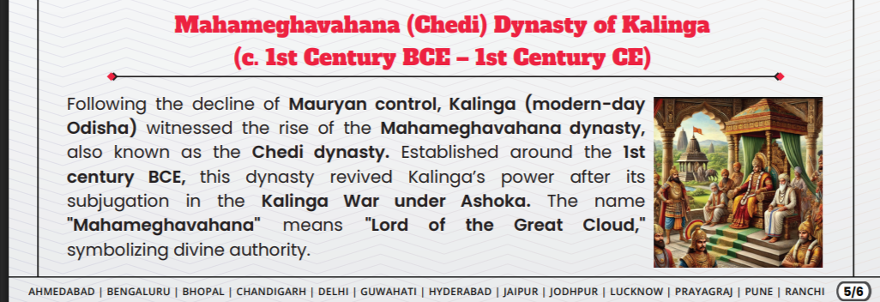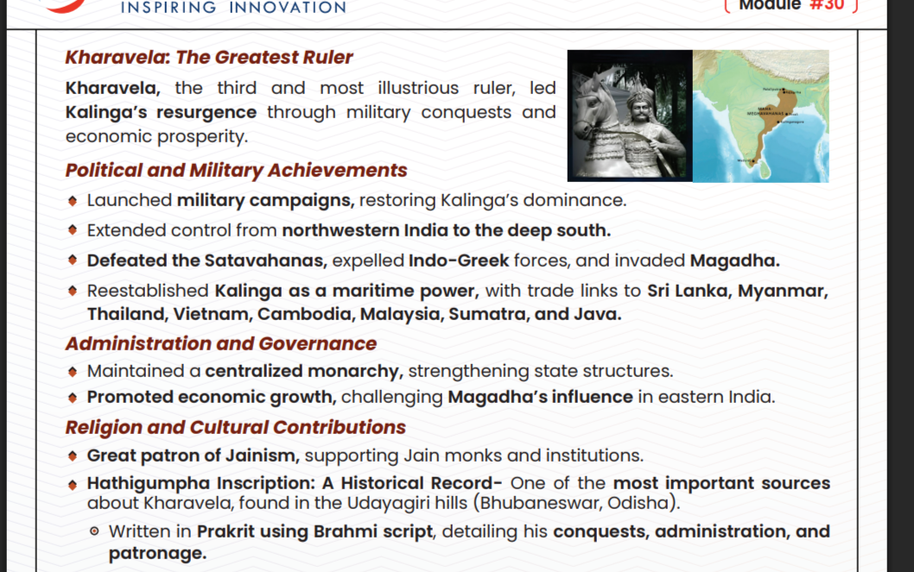
The Chedi Dynasty (c. 1st century BCE) was a powerful ruling house in Kalinga (modern Odisha), established by Mahameghavahana, whose most notable ruler was Kharavela. Known as the Mahameghavahana dynasty, they ruled after the Mauryan decline, with their history primarily derived from the Hathigumpha inscription in Bhubaneswar.
Next IAS +4
Key Aspects of the Chedi Dynasty
- Kharavela's Rule: The third and greatest ruler, King Kharavela, significantly expanded the kingdom and is celebrated in the Hathigumpha inscription.
- Infrastructure & Economy: Kharavela’s reign saw significant infrastructural advancements, including the improvement of irrigation canals and public works, boosting the region's prosperity
.
- Religion: The rulers, particularly Kharavela, patronized Jainism, though they maintained a policy of religious tolerance.
- Military Campaigns: Kharavela led successful military campaigns against surrounding kingdoms, including the Satavahana dynasty, restoring Kalinga's glory.
- Distinct from Mythical Chedi: This Kalinga-based dynasty is historically distinct from the earlier, semi-mythical Chedi kingdom of the Mahabharata era, which was located in central India (Bundelkhand) and ruled by Shishupala.
Wikipedia +5
The dynasty is generally considered to have been a powerful regional power during the post-Mauryan period, with a legacy tied closely to the cultural and military development of ancient Odisha.

Information regarding the total number of kings in the Chedi (or Mahameghavahana) dynasty of Kalinga is limited, as the primary source of history for this dynasty is the partially damaged Hathigumpha inscription.
Testbook
- Known Kings: While the dynasty ruled from the 1st century BCE, historical records primarily focus on King Kharavela.
- Genealogy: King Kharavela is identified as the third ruler of the Mahameghavahana/Chedi dynasty, succeeding his father.
- Successor: The Hathigumpha inscription suggests that Kharavela was succeeded by his son, Kudepasiri.
- Dynasty Scope: The Chedi dynasty, also known as Cheta or Chetavamsa, was based in Kalinga (modern-day Odisha).
Vajiram & Ravi +1
Note: While there are various mythological kings associated with the Chedi kingdom (e.g., Shishupala, Uparichara Vasu) mentioned in the Mahabharata, historical evidence specifically regarding the Chedi/Mahameghavahana dynasty of Kalinga in the post-Mauryan period is limited to only a few rulers

Here’s a clear, exam-ready summary of the Chedi (Cheta / Mahameghavahana) Dynasty in Kalinga 👇

🏛️ Chedi Dynasty (Kalinga) – Quick Notes
📍 Time & Region
- Period: 1st century BCE (Post-Mauryan period)
- Region: Kalinga (modern-day Odisha)
- Emerged after the decline of the Mauryan Empire

👑 Founder
- Traditionally attributed to King Abhichandra (as per some sources like coaching material)
- Dynasty also called:
  - Cheta / Chetavamsa
  - Mahameghavahana dynasty

⭐ Most Important Ruler: King Kharavela
- 3rd ruler of the dynasty
- Main source: Hathigumpha Inscription (Udayagiri Hills, near Bhubaneswar)
🔹 Achievements
- Expanded his kingdom through military campaigns
- Invaded regions in North and South India
- Promoted public works:
  - Built canals and irrigation systems
- Patron of art and architecture
🕉️ Religion
- Follower of Jainism
- Supported Jain monks and institutions

🏙️ Capital
- Suktimati / Puri region (exact identification debated by historians)

⚔️ Significance
- Major regional power in Post-Mauryan India
- Represents revival of Kalinga after Ashoka’s conquest
- Important for understanding:
  - Regional kingdoms
  - Early inscriptional history
  - Spread of Jainism

📜 Important Source
- Hathigumpha Inscription
  - Written in Prakrit (Brahmi script)
  - Provides a year-by-year account of Kharavela’s rule

⚠️ Exam Trap (Very Important)
Do NOT confuse:
- Chedi Dynasty (Kalinga, ancient, 1st century BCE)
❌ with
- Kalachuris of Chedi (medieval, Bundelkhand region)

🧠 One-line Revision
👉 Chedi (Mahameghavahana) dynasty of Kalinga rose in the 1st century BCE; its greatest ruler Kharavela is known from the Hathigumpha inscription and was a patron of Jainism.

If you want, I can convert this into MCQs, notes, or a revision chart for UPSC 👍
what is frangment dyansyt ya region
You’re probably asking about “fragmented dynasty / fragmented regions” (not “frangment dyansyt”)—a common UPSC concept.

📌 What is a Fragmented Region / Fragmentation?
Fragmentation means a large empire breaks into many smaller independent kingdoms or dynasties.

🏛️ In History (UPSC Context)
After the decline of a big empire (like the Mauryan Empire), India did not remain under one ruler. Instead:
➡️ Many regional powers emerged
➡️ Political unity broke
➡️ This period is called Political Fragmentation

🔎 Example
After Mauryan decline (2nd century BCE):
- Chedi (Kharavela) – Kalinga
- Shungas – North India
- Satavahanas – Deccan
- Indo-Greeks – North-West
👉 All these ruled separately, not as one empire

🧠 Simple Definition
👉 Fragmented region = Area divided into many small kingdoms instead of one big empire

⚡ One-line for UPSC
👉 Political fragmentation refers to the breakdown of a centralized empire into multiple regional states.

If you meant something else (like a specific dynasty name), tell me 👍

